**GDPR Standards for CATE Project**

**Data:**

The data will go through 5 steps, including:

1. **Extract:** Excel base extracted to the database.

As agreed with the company Dom Rock (parent company) no data will be discarded on the basis provided, that is, the analysis must be done with all data.

This data will be stored in a Mongo Cloud database that has nosql structure.

1. **Data cleansing:** Error checking on the database data.

In this step it will be checked if there is any data with error or null and it will be handled or discarded according to the guidance of the parent company.

1. **Data scope:** Creating a new collection of data needed for the final product.

In this step the clean data will be inserted into a new collection containing only the information needed for reporting.

1. **Relational bank:** Creation of a DW relational bank.

A new relational database will be created with the data coming from the previous step, thus preparing for display in the Power BI tool

1. **Data display:** Display of data in chart form.

The data is displayed by bringing the information through charts and reports by beneficiaries of the four possible cases that may occur.

**Access:**

Data manipulation will be feita through two levels of access.

* **Level 1:** Users responsible for steps 1 - Extraction and 2 - Data cleansing.

Only these users will have access to the complete database and the Mongodb Cloud database.

* Level 2: Users responsible for steps 3 - Data scope, 4 - Relational bank and 5 - Data display, being able to manipulate the data already processed by Level 1 users.

**Logs:**

In this project there is the traceability of the data through logs, where for this purpose there are the following models:

1. **General:** Saves information from all project data manipulation.
2. **Anonymizer:** Saves all anonymization information from the data used in the processes.
3. **Backuplog:** Concatenates all processes run on the day thus generating a backup of the logs executed.

Logs are generated automatically when a process starts. At the end, files are generated that can be consulted later, facilitating the traceability of information.

The following is the project-generated log model:

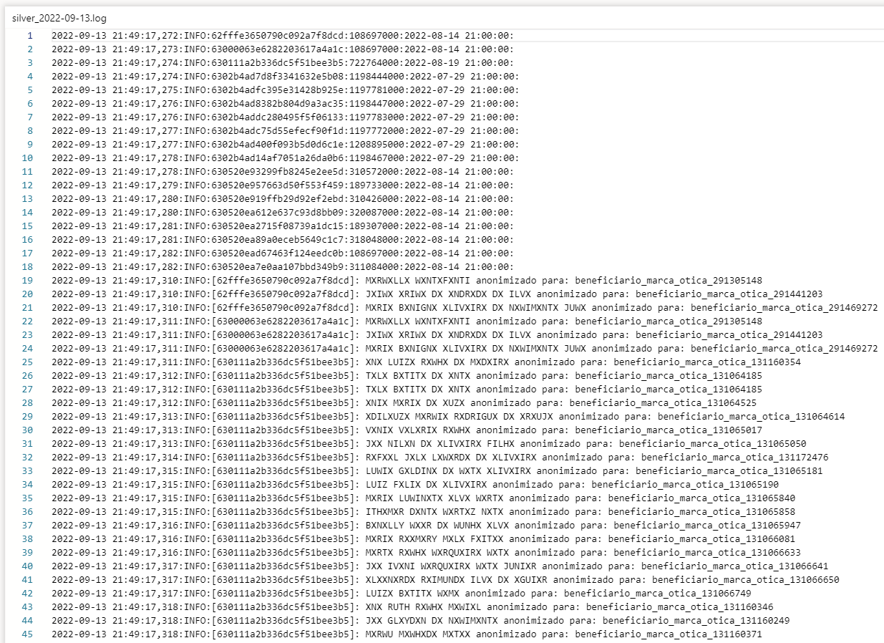

Being the stages of processing project data exposed and explained in the body of this document, it is agreed with the company Dom Rock that accepts the processes in the way it was presented.

Both parties to the agreement, we The Velopers have committed to the realization of the steps mentioned and described.